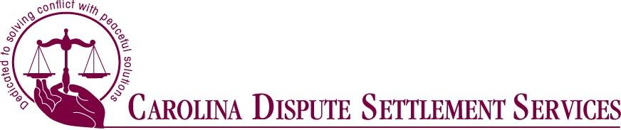

**Offered by Carolina Dispute Settlement Services**

**40/16­Hour NC Family Financial Mediation Online Training – March 20-March 31 2023**



Areas of discussion include:

* Negotiation theory
* Practical skills
* Rules
* Ethics

This course has been certified by the NC Dispute Resolution Commission

*A 16-hour option for experienced mediators is available. Contact CDSS for further information.* 

**Diann Seigle** Raleigh, NC Executive Director of Carolina Dispute Settlement Services

**Frank Laney**

Cary NC

Attorney/ Mediator

Guest Speaker:

**Tara Kozlowski** Raleigh, NC

Director of the North Carolina Dispute Resolution Commission

The 40-­‐ Hour Family Financial Settlement (FFS) mediation training program is a course designed for professionals interested in certifying through the NC Dispute Resolution Commission to mediate family financial and other divorce related claims. This 40-­‐Hour course teaches a six-­‐step mediation process and focuses on advanced mediation skills specific to the family and divorce arena. The 16-hour supplemental is also offered, Nov 1-4/2022.

Course: 40-­‐Hour Family Financial Settlement (FFS) Mediation

Date: March 20, 21, 22, 23, 24, 27,28, 29, 30, 31

(16-Hour supplemental is 3/28-31)

9:00a.m. – 1:00 p.m. for 10 days over 2 weeks,

ten 4-hour mornings

Location: Online Via Zoom

In this time of Covid-19, the Dispute Resolution Commission is allowing for online mediation certification training through the end of 2022. Once you have registered, you will receive a Zoom link and materials a few days before the training begins.

Other Details: There will be no lunch break, but one 15-minute break

Cost: $900 without CLE credit ($400 for 16-hour, $450 with 12 CLE) $990 with 24 hours of CLE for attorneys, including 2 hours of ethics (Must be mailed in with registration form)

Includes: All materials



First Name Last Name

 

NC Bar # (for CLE credit)

E-­‐mail __________________________________

Mailing address ______________________________

Phone ________________________________ City/State/Zip __________________________

For certification questions, please contact the NC Dispute Resolution Commission at (919) 890-­‐1415

Payment Method -­‐ Check (Please make checks payable to CDSS)

Mail registration form & Payment to:

CDSS 4600 Marriott Drive Suite 350

Raleigh NC 27612

Questions? Please call (919) 755-­‐4646 or Email: CDSS@notrials.com

We reserve the right to cancel/reschedule trainings due to lack of enrollment.

Please feel free to confirm by calling CDSS at (919) 755-­‐4646