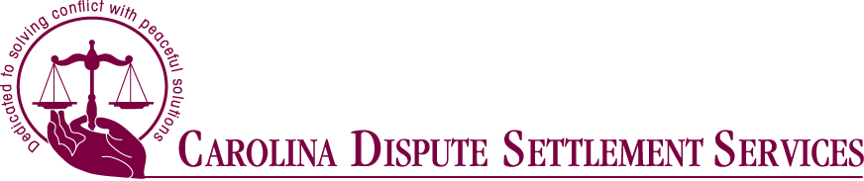

**Offered by Carolina Dispute Settlement Services**

**16-Hour NC Family Financial Mediation Training**

The 16- hour NC Family Financial Mediated Settlement Conference program training is a course designed for seasoned NC Superior Court mediators wishing to expand their mediation practice to include family financial settlement mediation. The program spends minimal time on the basics of mediation in order to focus on mediation skills specific to the family/divorce arena. Time is also spent identifying red flags for domestic violence and working with collaborative law attorneys.

Course: 16-Hour Family Financial

Date: \_\_\_\_\_\_\_\_\_\_\_\_\_\_\_\_\_\_\_\_\_\_\_\_\_\_\_\_\_\_\_\_\_ (please enter dates)

Time: 8:30am to 5:30pm

Location: Carolina Dispute Settlement Services

3737 Glenwood Avenue, Suite 370

Raleigh, NC 27612

Other Details:

Cost: $495.00 (Must be paid with registration)

Includes: Continental breakfast each day, materials, and CLE fees

\_\_\_\_\_\_\_\_\_\_\_\_\_\_\_\_\_\_\_\_\_\_\_\_\_\_\_\_\_\_\_\_\_\_ \_\_\_\_\_\_\_\_\_\_\_\_\_\_\_\_\_\_\_\_\_\_\_\_\_\_\_\_\_\_\_\_\_\_\_\_

First Name Last Name

\_\_\_\_\_\_\_\_\_\_\_\_\_\_\_\_\_\_\_\_\_\_\_\_\_\_\_\_\_\_\_\_\_\_ \_\_\_\_\_\_\_\_\_\_\_\_\_\_\_\_\_\_\_\_\_\_\_\_\_\_\_\_\_\_\_\_\_\_\_\_\_

NC Bar # (for CLE credit) E-mail

Top of Form

OSHR Mediator: Check Here 

\_\_\_\_\_\_\_\_\_\_\_\_\_\_\_\_\_\_\_\_\_\_\_\_\_\_\_\_\_\_\_\_\_\_ \_\_\_\_\_\_\_\_\_\_\_\_\_\_\_\_\_\_\_\_\_\_\_\_\_\_\_\_\_\_\_\_\_\_\_

Phone City/State/Zip

Payment Method – Check (Please make payable to CDSS)

Mail Registration Form & Payment to address listed above

For questions please call (919) 755-4646 or Email

CDSS@notrials.com

Bottom of Form

\_\_\_\_\_\_\_\_\_\_\_\_\_\_\_\_\_\_\_\_\_\_\_\_\_

Areas of discussion include:

* Equitable Distribution
* Custody
* Child Support
* Alimony
* Parenting Plans

\_\_\_\_\_\_\_\_\_\_\_\_\_\_\_\_\_\_\_\_\_\_\_\_\_\_\_\_

Diann Seigle

Raleigh, NC

Executive Director of CDSS

[Debbie Griffiths](http://www.griffithsfamilylaw.com/about-our-firm/" \t "_blank)  
Raleigh, NC  
Attorney at Law

Family Law Specialist  
  
[﻿﻿Leslie Ratliff﻿﻿](http://www.nccourts.org/Courts/CRS/Councils/DRC/Default.asp" \t "_blank)  
Raleigh, NC  
Director of the North Carolina  
​Dispute Resolution Commission

For certification questions, please contact the NC Dispute Resolution Commission at (919) 890-1415

We reserve the right to cancel/reschedule trainings due to lack of enrollment.

Please feel free to confirm by calling CDSS at (919) 755-4646